BCH codes
In this chapter Bose-Chaudhuri-Hocquenghem (BCH) codes are introduced and various BCH encoding and decoding algorithms are presented. BCH code encoding and decoding is considered. Three different decoding strategies are presented according to the error correcting capability of the code. Generally decoding is broken down into three processes, syndromes calculation, Berlekamp-Massey algorithm (BMA) and Chien search. In addition the BMA can be developed with or without inversion and both methods are described here. At the end of this chapter, comparisons between BCH codes and RS codes are presented.

Background
The first class of linear codes derived for error correction were Hamming codes [20]. These codes are capable of correcting only a single error but because of their simplicity, Hamming codes and their variations have been widely used in error control systems; e.g. the 16/32 bit parallel error detection and correction circuits SN54ALS616/SN54ALS632 [50]. Later the generalised binary class of Hamming codes for multiple-errors was discovered by Hocquenghem in 1959 [23], and independently by Bose and Chaudhuri in 1960 [6]. Subsequently, non-binary error-correcting codes were derived by Gorenstein and Zieler [19]. Almost at the same time independently of the work of Bose, Chaudhuri and Hocquenghem, the important subclass of non-binary BCH codes - RS codes - were introduced by Reed and Solomon [44].

This project is concerned with BCH codes however and these codes are described in more detail below.

BCH codes
The class of BCH codes is a large class of error correction codes that occupies a prominent place in theory and practice of error correction. This prominence is a result of the relatively simple encoding and decoding techniques. Furthermore, provided the block length is not excessive, there are good codes in this class ([30] Chapter 9). In this thesis only the subclass of binary BCH codes is considered as these codes can be simply and efficiently implemented in digital hardware.

Before considering BCH codes, some additional theory needs to be introduced.

Theorem 3.1. ([30], p.10) The minimum distance of a linear code is the minimum Hamming weight of any non-zero codeword.

Theorem 3.2. ([30], p.10) A code with minimum distance d can correct
⎣ (d-1)/2 ⎦ errors.

Definition 3.2. A linear code C is cyclic if whenever (c₀, c₁, ..., c_{n-1}) ∈C then so is (c_{n-1}, c₀, c₁, ..., c_{n-2}).

A codeword (c₀, c₁, ..., c_{n-1}) of a cyclic code can be represented as the polynomial c(x) = c₀ + c₁x + .... + c_{n-1}x_{n-1} . This correspondence is very helpful as the mathematical background of polynomials is well developed, and so this representation is used here.

It is frequently convenient to define error-correcting codes in terms of the generator polynomial of that code g(x) [29]. The generator polynomial of a t-error-correcting BCH code is defined to be the least common multiple (LCM) of f₁, f₃, ... f_{2*t-1}, that is,
g(x) = LCM{ f₁, f₃, f_{5,} ... f_{2*t-1}} (3.1)
where f_{j} is the minimal polynomial of α^{j} (0 < j < 2t + 1) considered below.

Let f_{j} (0 < j < 2t + 1) be a minimal polynomial of α^{j} then f_{j} is obtained by (Theorem 2.14, [29]):
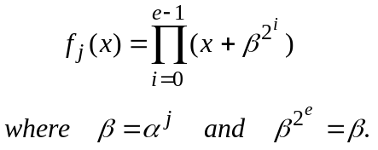 (3.2)
According to Theorem 2.15 [29] e ≤ m.
To generate a codeword for an (n, k) t error-correcting BCH code, the k information symbols are formed into the information polynomial i(x) = i₀ + i₁x +...+ i_{k-1}x^{k-1} where i_{j} ∈ GF(2). Then the codeword polynomial c(x) = c₀ + c₁x + ... + c_{n-1}x^{n-1} is formed as
c(x) = i(x)*g(x). (3.3)
Since the degree of f_{j}(x) is less or equal to m (e ≤ m equ(3.2); [29] p. 38), from equ(3.1) the degree of the g(x) (and consequently the number of parity bits n-k) is at most equal to m*t. For small values of t, the number of parity check bits is usually equal to m*t ([29] p. 142).

For any positive integer m ≥ 3 there exists binary BCH codes (n, k) with the following parameters:
n = 2^{m} - 1 length of codeword in bits
t the maximum number of error bits that can be corrected
k ≥ n - m * t number of information bits in a codeword
d_{min} ≥ 2*t + 1 the minimum distance.

A list of BCH code parameters for m ≤ 10 is given in Appendix D. Note that for t = 1, this construction of BCH codes generates Hamming codes. The number of parity bits equals m, and so (2^{m} - 1, 2^{m} - m -1) codes are obtained. In this case the generator polynomial g(x) satisfies
g(x) = f₁(x) = p(x)
where p(x) is the irreducible polynomial for GF(2^{m}) as given, for example, in Appendix A.

In this thesis only primitive BCH codes are considered. Binary non-primitive BCH codes can be constructed in a similar manner to primitive codes ([29] p.151). Non-primitive BCH codes have a generator polynomial g(x) with
β^{l}, β^{l+1}, β^{l+2}, ... , β^{l+d-2}

as roots, where β is an element in GF(2^{m}) and l is a non-negative integer. Non-primitive BCH codes obtained in this way have a minimum distance of at least d. When l = 1, d = 2* t + 1 and β = α where α is a primitive element of GF(2^{m}), primitive BCH codes are obtained.

Encoding BCH codes
If BCH codewords are encoded as in equ(3.3) the data bits do not appear explicitly in the codeword. To overcome this let
c(x) = x^{n-k} * i(x) + b(x) (3.4)
where c(x)= c₀ + c₁x +...+ c_{n-1}x^{n-1}, i(x)= i₀ + i₁x +...+ i_{k-1}x^{k-1}, b(x)= b₀ + b₁x +...+ b_{m-1}x^{m-1} and c_{j}, i_{j}, b_{j} ∈ GF(2). Then if b(x) is taken to be the polynomial such that
x^{n-k} * i(x) = q(x) * g(x) - b(x) (3.5)
the k data bits will be present in the codeword. (By implementing equ(3.4) instead of equ(3.3) systematic ([29] p. 54) codewords are generated).

BCH codes are implemented as cyclic codes [42], that is, the digital logic implementing the encoding and decoding algorithms is organised into shift-register circuits that mimic the cyclic shifts and polynomial arithmetic required in the description of cyclic codes. Using the properties of cyclic codes [29, 30], the remainder b(x) can be obtained in a linear (n-k)-stage shift register with feedback connections corresponding to the coefficients of the generator polynomial g(x) = 1 + g₁x + g₂x² + ... + g_{n-k-1}x^{n-k-1} + x^{n-k}. Such a circuit is shown on Figure 3.1.
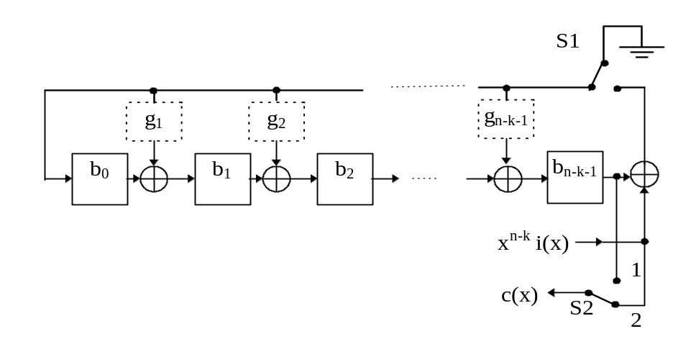
Figure 3.1. Encoding circuit for a (n, k) BCH code.

The encoder shown in Figure 3.1 operates as follows
- for clock cycles 1 to k, the information bits are transmitted in unchanged form (switch S2 in position 2) and the parity bits are calculated in the Linear Feedback Shift Register (LFSR) (switch S1 is on).
- for clock cycles k+1 to n, the parity bits in the LFSR are transmitted (switch S2 in position 1) and the feedback in the LFSR is switch off (S1 - off).

As an example, the (15, 5) 3-error correcting BCH code is considered. The generator polynomial with α, α², α³, ... , α⁶ as the roots is obtained by multiplying the following minimal polynomials:

roots | minimal polynomial
α, α², α⁴ | f₁(x) = (x+α) * (x+α²) * (x+α⁴) * (x+α⁸) = 1 + x + x⁴
α³, α⁶ | f₃(x) = (x+α³) * (x+α⁶) * (x+α¹²) + (x+α⁹) = 1 + x + x² + x³ + x⁴
α⁵ | f₅(x) = (x+α⁵) * (x+α¹⁰) = 1 + x + x²

Thus the generator polynomial g(x) is given by
g(x) = f₁(x) * f₃(x) * f₅(x) = 1 + x + x² + x⁴ + x⁵ + x⁸ + x¹⁰.

Decoding BCH codes
The decoding process is far more complicated than the encoding process. As a general rule, decoding can be broken down into three separate steps:
- Calculating the syndromes
- Solving the key equation
- Finding the error locations.
Fortunately, for some BCH codes step number 2 can be omitted. To decode BCH codes in this thesis, three different strategies have been employed, for single error correcting (SEC), double error correcting (DEC) and triple and more error correcting (TMEC) BCH codes.
Regarding step 1, the calculation of the syndromes is identical for all BCH codes. For SEC codes step number 2 - solving the key equation - can be omitted, as a syndrome gives rise to the error location polynomial coefficient. For DEC codes step number two can also be omitted but the error location algorithm is rather more complicated. Finally, when implementing the TMEC decoding algorithm all three steps must be carried out, where step 2 - the solution of the key equation - is the most complicated.

Calculation of the syndromes
Let
c(x) = c₀ + c₁x + c₂x² + ... + c_{n-1}x^{n-1}
r(x) = r₀ + r₁x + r₂x² + ... + r_{n-1}x^{n-1}
e(x) = e₀ + e₁x + e₂x² + ... + e_{n-1}x^{n-1} (3.6)
be the transmitted polynomial, the received polynomial and the error polynomial respectively so that
r(x) = c(x) + e(x). (3.7)
The first step of the decoding process is to store the received polynomial r(x) in a buffer register and to calculate the syndromes S_{j} (for 1 ≤ j ≤ 2t -1). The most important feature of the syndromes is that they do not depend on transmitted information but only on error locations, as shown below.

Define the syndromes S_{j} as
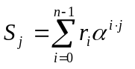 for (1 ≤ j ≤ 2t). (3.8)
Since r_{j} = c_{j} + e_{j} (j = 0, 1, ...., n-1)
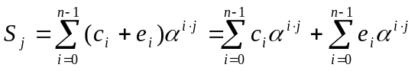 . (3.9)
By the definition of BCH codes
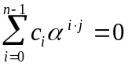 for (1 ≤ j ≤ 2t) (3.10)
thus
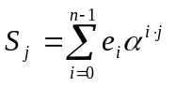 . (3.11)
It is therefore observed that the syndromes S_{j} depends only on the error polynomial e(x), and so if no errors occur, the syndromes will all be zero.

To generate the syndromes, express equ(3.8) as
S_{j} = (...((r_{n-1} * α^{j} + r_{n-2}) * α^{j} + r_{n-3}) * α^{j} + ....) * α^{j} + r₀. (3.12)
Thus a circuit calculating the syndrome S_{j} carries out (n-1) multiplications by the constant value α^{j} and (n-1) single bit summations. Note that because r_{j}∈GF(2) the equation S_{2i} = S_{i}² is met [29].

For example a circuit calculating S₃ for m = 4 and p(x) = x⁴ + x + 1 is presented in Figure 3.2. Initially the register s_{i} (0 ≤ i ≤ 3) is set to zero. Then the register s₀ - s₃ is shifted 15 times and the received bits r_{i} (0 ≤ i ≤ 14) are clocked into the syndrome calculation circuit. Then the S₃ is obtained in the s₀ - s₃ register.
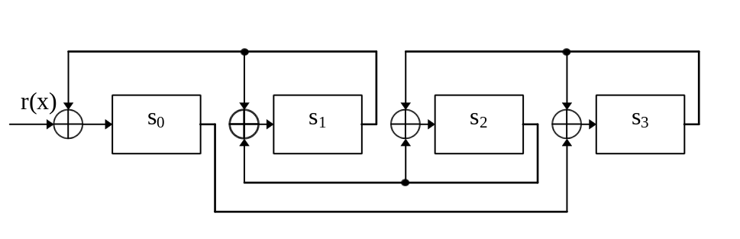
Figure 3.2. Circuit computing S₃ for m = 4.

Syndromes can also be calculated in a second way ([29] p. 152, 165), ([30] p. 271). Employing this approach, S_{j} is obtained as the remainder in the division of the received polynomial by the minimal polynomial f_{j}(x), that is,
r(x) = a_{j} * f_{j}(x) + b_{j}(x) (3.13)
where
S_{j} = b_{j}(α^{j}). (3.14)
It should be mentioned that the minimal polynomials for α, α², α⁴, .... are the same and so only one register is required to calculate the syndromes S₁, S₂, S₄, ... . The rule can be extended for S₃, S₆, ..., and so on.

For example the circuit calculating S₃ for m = 4 is shown in Figure 3.3. The minimal polynomial of α³ is
f₃(x) = 1 + x + x² + x³ + x⁴
and let b(x) = b₀ + b₁x + b₂x² + b₃x³ be the remainder on dividing r(x) by f₃(x). Then
S₃ = b(α³) = b₀ + b₁α³ + b₂α⁶ + b₃α⁹ = b₀ + b₃α + b₂α² + (b₁ + b₂ + b₃) α³.
The circuit in Figure 3.3 therefore operates by first dividing r(x) by f₃(x) to generate b(x) and then calculating b(α³). The result is obtained after the register b₀ - b₃ have been clocked 15 times.
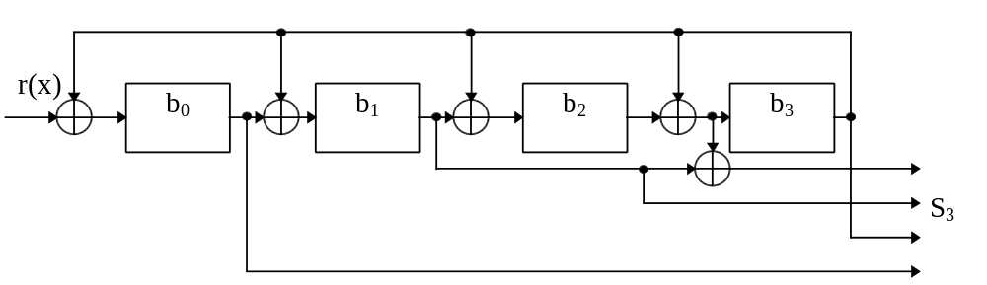
Figure 3.3. Second method of computing S₃ for m = 4.

Solving the key equation
The second stage of the decoding process is finding the coefficients of the error location polynomial σ(x) = σ₀ + σ₁x + ... + σ_{t}x^{t} using the syndromes S_{j} (1 ≤ j < 2t). The relationship between the syndromes and these values of σ_{j} is given by ([5], p.168)
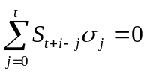 (i= 1, ..., t) (3.15)
and the roots of σ(x) give the error positions. The coefficients of σ(x) can be calculated by methods such as the Peterson-Gorenstein-Zieler algorithm [5, 43] or Euclid’s algorithm [49]. In this thesis the Berlekamp-Massey Algorithm (BMA) [2, 32] has been used as it has the reputation of being the most efficient method in practice [5].

In the BMA, the error location polynomial σ(x) is found by t-1 recursive iterations. During each iteration r, the degree of σ(x) is usually incremented by one. Through this method the degree of σ(x) is exactly the number of corrupted bits, as the roots of σ(x) are associated with the transmission errors. The BMA is based on the property that for a number of iterations r greater or equal the number of errors t_{a} that have actually occurred (r ≥ t_{a}), the discrepancy d_{r} = 0 in equ (3.16) below where
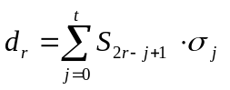. (3.16)
On the other hand if r < t_{a}, the discrepancy d_{r} calculated in equ(3.16) is usually non zero and is used to modify the degree and coefficients of σ(x). What the BMA essentially does therefore is compute the shortest degree σ(x) such that equ(3.15) holds.

The BMA with inversion is given below.
Initials values:
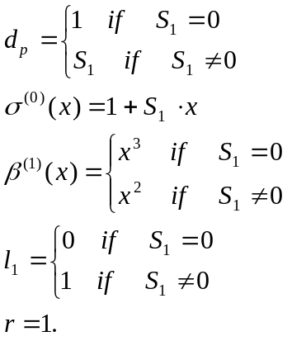 (3.17)
The error location polynomial σ(x) is then generated by the following set of recursive equations:
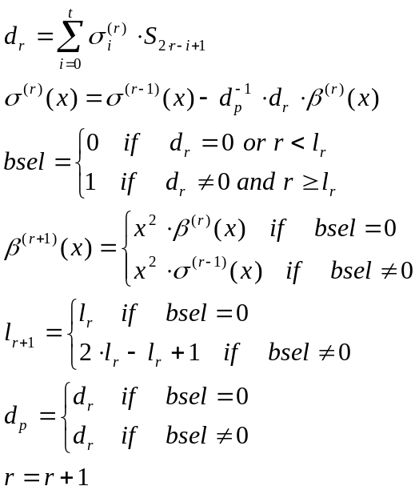 (3.18)
these calculation are carried out for r= 1, ..., t-1.
Note that the above algorithm is slightly modified in comparison with the previously presented BMA [2, 32]. Due to more complicated initial states, the number of iterations is decreased by one. In practice, this causes only a slight increase in the hardware requirements but the BMA calculation time is significantly reduced.
A circuit implementing the BMA is given in Figure 3.4. The error location polynomial σ(x) is obtained in the C registers after t-1 iterations.

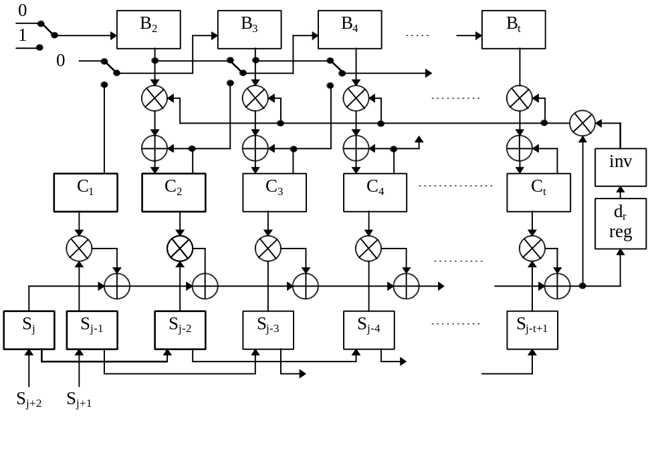
Figure 3.4. Berlekamp Massey Algorithm with inversion.

In some applications it may be beneficial to implement the BMA without inversion. A version of the BMA achieving this was presented in [8, 56]. For inversionless BMA the initial conditions are the same as for the BMA with inversion given in equ(3.17). The error location polynomial is then generated by following recursive equations:
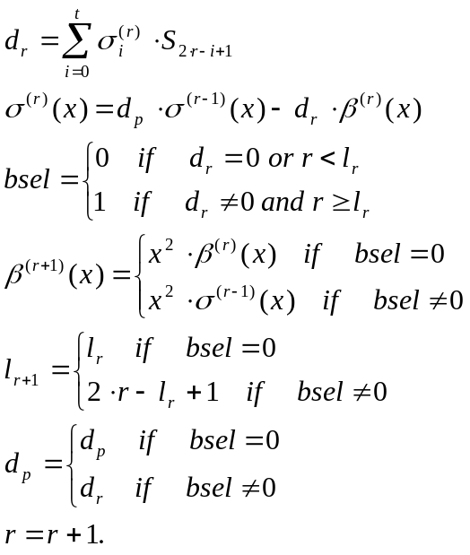 (3.19)
In conclusion, inversionless BMA is more complicated and requires a greater number of multiplications than the BMA with inversion. On the other hand, inversion can take (m-1) clock cycles (see Section 2.7) and therefore even if parallel multiplication is used this constraint will slow down the algorithm. Therefore the inversionless algorithm has to be implemented for some BCH codes.

For SEC and DEC BCH codes the coefficients of σ(x) can be obtained directly without using the BMA. This is because for SEC BCH codes
σ(x) = 1 + S₁x
and for DEC BCH codes
σ(x) = 1 + σ₁x + σ₂x² = 1 + S₁x + (S₁² + S₃ * S₁⁻¹) x²
[2], ([30] p. 321). This approach for generating σ(x) directly in terms of the syndromes can be theoretically extended to TMEC but quickly becomes too complex to implement in hardware and so the BMA must be used.

Finding the error locations

General case
The last step in decoding BCH codes is to find the error location numbers. These values are the reciprocals of the roots of σ(x) and may be found simply by substituting 1, α, α², ... , α^{n-1} into σ(x). A method of achieving this using sequential substitution has been presented by Chien [10]. In the Chien search the sum
σ₀ + σ₁α^{j} + σ₂α^{2j} + ... + σ_{t}α^{tj} (j= 0, 1, ... , k-1) (3.20)
is evaluated every clock. It can be noticed that if σ(α^{j})= 0, the received bit r_{n-1-j} is corrupted. Therefore if for clock cycle j the sum equals zero the received bit r_{n-j-1} should be corrected.

A circuit implementing the Chien search is shown in Figure 3.5. The operation of this circuit is as follows. The registers c₀, c₁, ..., c_{t} are initialised by the coefficients of the error location polynomial σ₀, σ₁, ... , σ_{t}. Then the sum 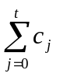 is calculated and if this equals zero, the error has been found and after being delayed in a buffer, the faulty received bit is corrected using an XOR gate. On the next clock cycle each value in the c_{i} register is multiplied by α^{i} (using a constant multiplier), and the sum is calculated again. The above operations are carried out for every transmitted information bit (that is k times).
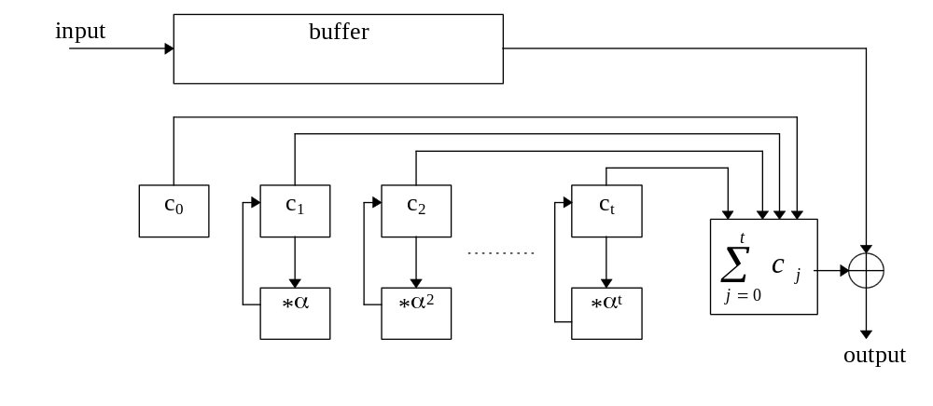
Figure 3.5 Chien’s search circuit.

Finding an error location for t = 2
In the case of DEC BCH codes, two different algorithms may be adopted. Firstly, one may adopt the general procedure, namely finding the syndromes, implementing the relatively burdensome BMA and then adopting Chien search. In this thesis however another approach has been adopted [53]. This algorithm does not require the error location polynomial σ(x) to be generated, instead a more sophisticated error location procedure is adopted. This algorithm is summarised below.

Suppose the received vector has at most two errors, then the error location polynomial σ(x) is given by [2] ([30] p. 321):
σ(x) = 1 + σ₁x + σ₂x² = 1 + S₁x + (S₁² + S₃ * S₁⁻¹) x². (3.21)
Therefore if there is no error σ₁ = 0 and σ₂ = 0, thus
S₁ = 0 S₃ = 0. (3.22)
If only one error has occurred σ₁ ≠ 0 and σ₂ = 0, thus
S₁ ≠ 0 S₃ = S₁³. (3.23)
If there are two errors σ₁ ≠ 0 and σ₂ ≠ 0, thus
S₁ ≠ 0 S₃ ≠ S₁³. (3.24)
If S₁ = 0 and S₃ ≠ 0 more than two errors have occurred and so the error pattern cannot be corrected.

This step-by-step decoding algorithm is based around the assumption that an error has occurred at the present location. Accordingly the values in the s₁ and s₃ registers are changed. These changes are easily implemented because if the received bit r_{n-1} is corrupted, only the first bits s_{i,0} of the registers s₁ and s₃ need be negated where s_{i} = s_{i,0} + s_{i,1}x + ... + s_{i,m-1}x^{m-1} for (i=1,3) and the s₁ and s₃ registers hold the values of S₁ and S₃ respectively. Similarly, assuming that the received bit r_{n-1-j} is corrupted, the syndrome registers are clocked j-times implementing the function s_{i} ← s_{i} * α^{i} (with a circuit similar to the syndrome calculation circuit) and so only the first bits s_{1,0} and s_{3,0} are negated [53].

A circuit employing this algorithm is given in Figure 3.6. At first registers s₁ and s₃ are initiated with S₁ and S₃ respectively and using equ(3.22-24), the number of errors present are stored by clocking values h₁, h₃ into flip-flops p₁, p₃. It is then assumed that an error has occurred in the first position. The registers s₁ and s₃ are updated and again using equ(3.22-24) the new number of errors present is specified. If the new number of errors has decreased, the assumption has proven to be correct and an error has been found. That is, the received bit r_{n-1} is corrected and the error assumption changes are introduced permanently into the s₁ and s₃ registers. In addition, the p flip-flops are clocked with the new h signals. Alternatively, if the number of errors has not decreased, the assumption is wrong and the correct bit has been received and the changes are cancelled. The above operations are repeated for every received information bit r_{n-1-j} (0 ≤ j < k), after the s registers have been shifted (s_{i} ← s_{i} * α^{i}, i= 1,3) j-times.
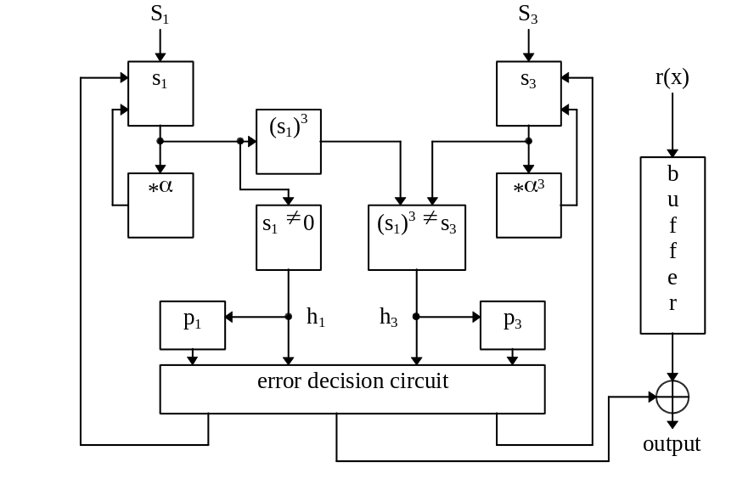
Figure 3.6. Error location circuit for t = 2.

Reed-Solomon codes
In this thesis only binary BCH codes have been considered and only their hardware representation developed. Therefore here a comparison between binary BCH codes and non-binary BCH codes, the sub-class of RS codes [44] is considered. RS codes are the most efficient error correcting codes theoretically possible and a wide body of knowledge concerning them exists [5,30]. In addition, RS codes are especially attractive as they can correct not only random but burst errors as well. In many situations the information channel has memory, and so random binary BCH codes are not appropriate. Fortunately, binary BCH codes can correct burst errors when an interleaved code with large t is adopted. But as will be shown below, this architecture is not recommended and instead, RS codes should be used.

RS codes operate on symbols consisting of m-bits and which are elements of GF(2^{m}). Each codeword consists of (n= 2^{m}-1, k= 2^{m}-1-2t) such symbols, where t is the maximum number of symbols that may be corrected.

Now the decoding of RS codes will briefly be presented in comparison with BCH codes. The encoding process is omitted here as it is relatively simple, and therefore only slightly influences a codec’s complexity. There are two different ways of decoding RS codes [5,16] in the time or in the frequency domain. Here frequency domain decoding process will be considered.
Decoding may be separated into four main areas
1. Calculation of syndromes using equation:
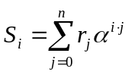 0≤ i< 2t (3.25)
where the r_{j} ∈ GF(2^{m}) are the received symbols (see also equ(3.8)).
Note that the calculation of the syndromes for BCH codes is simpler (r_{i}∈GF(2)) than for RS codes because r_{i} ∈GF(2^{m}) and so the equation S_{i}² =S_{2i} does not hold for RS codes.
2. Berlekamp-Massey Algorithm. The BMA is similar as in the case of BCH codes but requires twice as many iterations (taking the same value of t).
3. Recursive extension, computing the equation
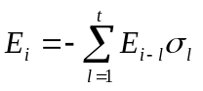 2t ≤ i ≤ n-1 (3.26)
where E_{i} = S_{i} 0≤ i ≤ 2t-1.
Youzhi [56] has shown that this step can be implemented with a BMA circuit by adding only additional control signals.
4. Obtaining the error magnitudes e_{i} by computing the inverse transforms
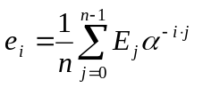 2t ≤ i ≤ n-1. (3.27)
This step is not required for BCH codes and in comparison to the Chien search is rather more complicated.

If binary BCH codes and non-binary RS codes are compared, at first it may seem that BCH codes are much simpler to implement. This is because RS codes operate on symbols and require additional steps to be computed since not only do the error locations have to be calculated (as with BCH codes) but also the error magnitudes. But after closer consideration, it may be seen that for example, a (15, 11) RS code can correct up to two corrupted 4-bit symbols, e.g. at least one 5-bit burst error. This code consists of 4*15= 60 codeword bits and 4*11= 44 information bits. Conversely, consider a similar (63, 36) 5 bits random error correcting BCH code. It should be noted here that this comparison of BCH and RS codes is not based on any practical experiments and in practice maybe different codes should be considered. This BCH code has not only a lower information rate (k/n) but more hardware is needed to the decoder. Consequently, calculation of the syndromes is simpler in comparison with the RS code, but a greater number of syndromes must be computed. Furthermore, the BMA is much more complex for the BCH code as the number of errors is greater. RS codes also require the inverse transform calculation to be implemented and this is more complicated than the equivalent Chien search circuit. But taken overall, the hardware requirements of the RS codec are much simpler. In addition the BCH code requires all the operations to be carried out over GF(2⁶), whereas the RS code operates over GF(2⁴), and so more complex arithmetic circuits are required for BCH codes.

In conclusions, RS codecs generally have more attractive properties and they should rather be implemented if burst errors have to be corrected.

Conclusions
In this chapter BCH codes have been introduced. Encoding and decoding algorithms for BCH codes with different error-correcting abilities have been considered. Decoders have more complex structure than encoders and so the decoding process has been broken down into three separate steps. The first step is the syndrome calculation process, an identical process whatever the error-correcting ability of the code. The next step is to find the error location polynomial σ(x). This stage is the most complicated of the three and for DEC BCH codes, an alternative decoding algorithm is used which by-passes the need to generate this polynomial entirely. For TMEC BCH codes σ(x) is calculated using the relatively complex BMA, whereas for SEC BCH codes, σ(x) can be expressed immediately in terms of the syndromes. The last stage of decoding is to find and correct any errors present. Two different approaches have been employed to achieve this, one for the general case and one for DEC BCH codes.

